**Name-Ayan Sadhukhan**

**Regd No-19BEC1448**

***Question 1:***

Write an algorithm and the subsequent C code to compute the degree of each vertex to a given graph G=(V,E) where V is a vertex set and E is an edge set. Check your C code to following inputs

***Code:***

#include<iostream>

using namespace std;

struct graph

{

int v;

int e;

int **dir;

};

int findDegree(struct graph *G, int ver)

{

int degree = 0;

for (int i=0; i<G->v; i++)

if (G-> dir[ver][i] == 1)

degree++;

return degree;

}

struct graph *createGraph(int v,int e)

{

struct graph *G = new graph;

G->v = v;

G->e = e;

G->dir = new int*[v];

for (int i = 0;i < v;i++)

G->dir[i] = new int[v];

G->dir[0][1]=1;

G->dir[0][2]=1;

G->dir[0][3]=1;

G->dir[1][0]=1;

G->dir[1][3]=1;

G->dir[2][0]=1;

G->dir[2][3]=1;

G->dir[3][0]=1;

G->dir[3][1]=1;

G->dir[3][2]=1;

return G;

}

int main()

{

int vertices = 4;

int edges = 5;

struct graph *G = createGraph(vertices, edges);

int ver = 0;

for(int i=1;i<=vertices;i++)

cout<<findDegree(G, i)<<" is the degree of the "<<i<<"th vertice"<<endl;

return 0;

}

***Output:***

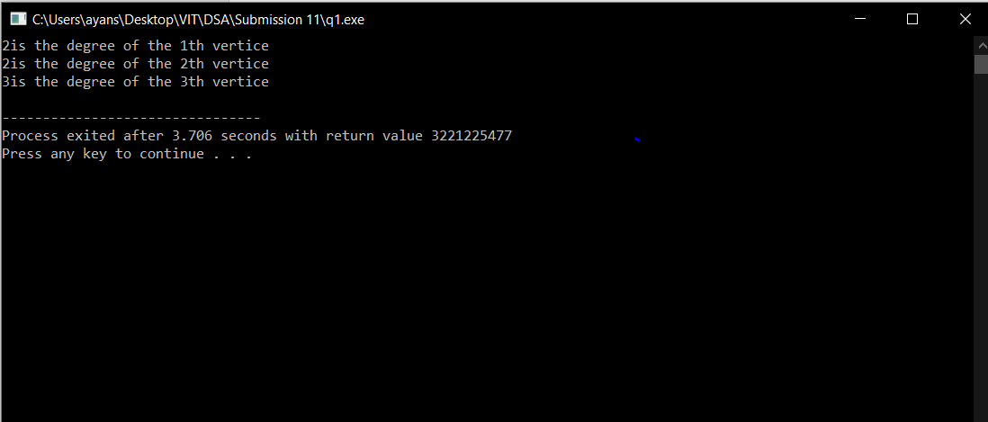

***Question 2:***

Write an algorithm and the subsequent C code to check whether a given path P is simple path or not. Check your C code for paths P1 and P2 of the above graphs.

***Code:***

***Output:***